Shri Ramswaroop Memorial University
Lucknow- dewa road, Barabanki, India


Session: 2025-26
INNOVATIVE T.T
Computer Organization and Architecture
(UCS 4012)
REPORT FILE

Submitted by: Submitted to:
Name : Hina Siddiqui Dr. Akhilesh Kumar Gupta
Roll no : 202410101150223
Course : B. Tech CS [DS+AI]
Group : CS-DS-47, 48

TITLE:- Human Stress Level Simulator Based on Workload.

• CODE :-
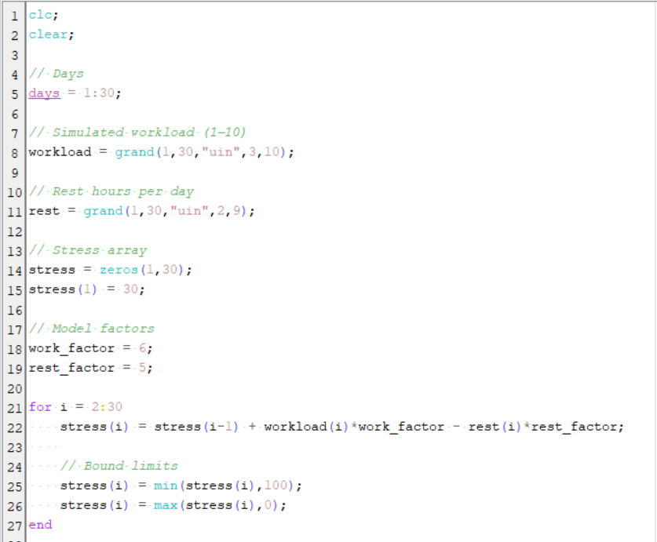

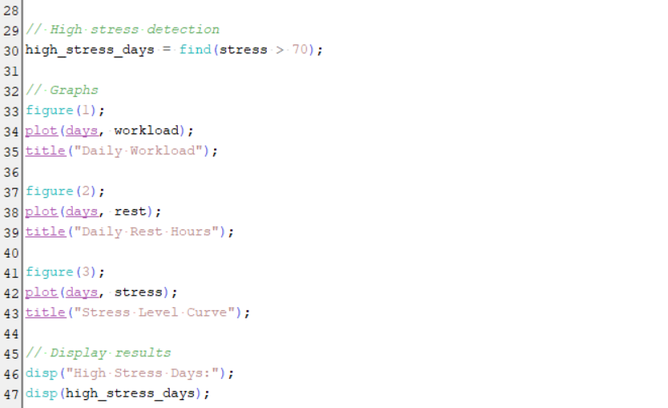

OUTPUT:-

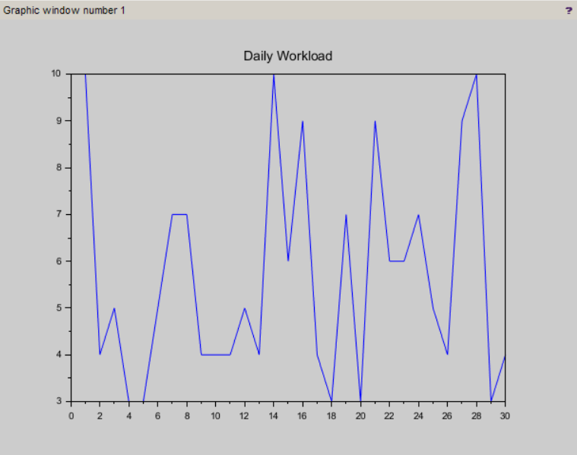

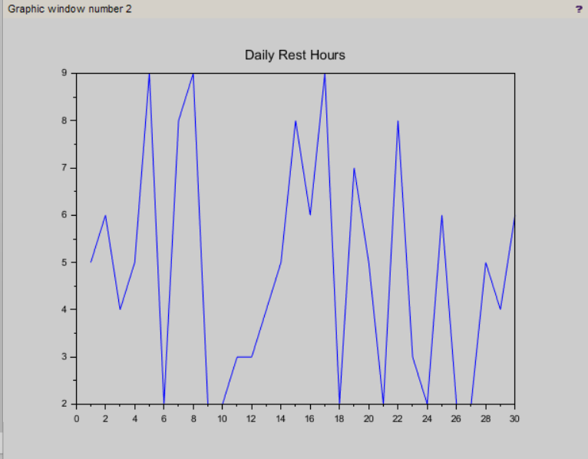

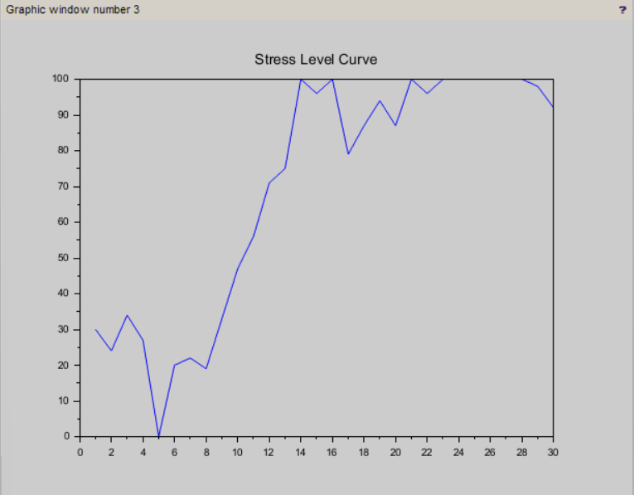

• Introduction :-
Human stress is a common issue in modern life, especially among students and working professionals. Stress depends on factors such as workload, rest, and deadlines.
This project simulates a human stress level system using Scilab. The system calculates stress as a numerical value and shows how it changes over time based on workload. It also helps in identifying burnout conditions.

• Objective :-
The objectives of this project are:
➢ To simulate human stress levels based on workload
➢ To analyze the effect of rest on stress
➢ To detect burnout conditions
➢ To visualize stress variation using graphs
➢ To understand numerical simulation

• Problem Statement :-
In real life:
➢ Stress cannot be measured directly
➢ It depends on multiple factors
➢ Burnout is difficult to identify early
This project provides:
➢ Simple stress calculation
➢ Easy understanding
➢ Low-cost simulation
➢ Practical demonstration

• Literature Review :-
Stress analysis is used in:
➢ Psychology research
➢ Workplace productivity analysis
➢ Health monitoring systems

Many systems consider:
➢ Workload impact
➢ Rest and recovery
➢ Time pressure
This project uses a simplified numerical model to simulate stress behavior.

• System Design :-
We model stress using a numerical system.
Input → Processing → Output
Inputs:
- Workload
- Rest
- Deadline
Processing:
- Stress calculation formula
Output:
- Stress graph
- Burnout alert

• Methodology:-
1. Input Collection :-
Workload, rest, and deadline values are generated.
2. Stress Calculation:-
Stress is calculated using:
S(t+1) = S(t) + Workload + Deadline − Rest

3. Iteration :-
Stress is updated daily using a loop.
4. Burnout Detection :-
If stress > 85 → burnout condition.

• Software Required :-
➢ Scilab

• Application :-
Applications include:
• Student stress monitoring
• Employee workload analysis
• Productivity tracking
• Mental health awareness

• Advantages :-
Advantages
• Simple and easy to understand
• No hardware required
• Low cost
• Useful for learning
• Numerical modeling:

• Limitation :-
Limitations:
• Uses simulated data
• Not real-time system
• Simplified model
• Not medically accurate

• Future Scope :-
Future improvements:
• Real-time data collection
• Mobile application
• AI-based stress prediction
• Integration with wearable devices

• Conclusion :-
The project successfully simulates human stress levels based on workload using Scilab. It helps in understanding how stress changes over time and identifies burnout conditions. This project is useful for learning numerical modeling and real-life problem simulation.

